Project Design Phase-II
Data Flow Diagram & User Stories

Date | 02 February 2026
Team ID | LTVIP2026TMIDS34601
Project Name | TransLingua
Maximum Marks | 4 Marks

Data Flow Diagrams:
A Data Flow Diagram (DFD) is a traditional visual representation of the information flows within a system. A neat and clear DFD can depict the right amount of the system requirement graphically. It shows how data enters and leaves the system, what changes the information, and where data is stored.

Example: (Simplified)

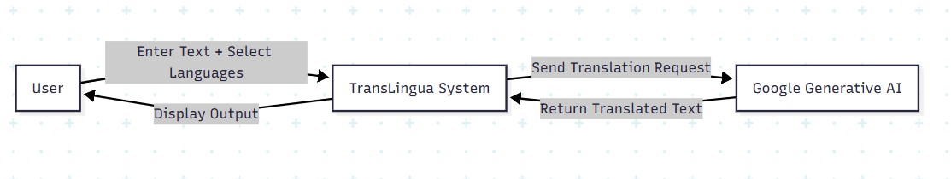

User Stories
User Type | Functional Requirement (Epic) | User Story Number | User Story / Task | Acceptance criteria | Priority | Release
End User (Web) | Text Translation | USN-1 | As a user, I can enter text (up to 3000 characters) in the input area for translation. | Text area accepts input and displays character count. | High | Sprint-1
End User (Web) | Text Translation | USN-2 | as a user, I can select a source language from a dropdown of 25+ languages. | Dropdown displays all supported languages including "Auto-Detect". | High | Sprint-1
End User (Web) | Text Translation | USN-3 | As a user, I can select a target language from a dropdown. | Dropdown displays all supported languages (excluding "Auto-Detect"). | High | Sprint-2
End User (Web) | Text Translation | USN-4 | As a user, I can click "Translate" to get the translation of my input text. | Translated text is displayed side-by-side with original text. | High | Sprint-1
End User (Web) | Auto Detection | USN-5 | As a user, I can select "Auto-Detect" as source language and the system will identify the input language. | The detected language name is displayed before translation begins. | High | Sprint-1
End User (Web) | Auto Detection | USN-6 | As a user, I can see the "Auto-Detection Active" indicator when Auto-Detect is selected. | A pulsing indicator shows that auto-detection mode is enabled. | Medium | Sprint-1
End User (Web) | Translation Controls | USN-7 | As a user, I can click "Swap" to interchange source and target languages. | Languages swap positions in the dropdowns. | Medium | Sprint-2
End User (Web) | Translation Controls | USN-8 | As a user, I can click "Copy" to copy the translated text. | Translated text can be copied to clipboard. | Medium | Sprint-2
End User (Web) | Translation Controls | USN-9 | As a user, I can click "Reset" to clear all inputs and start a new translation. | All fields are cleared and the interface resets. | Medium | Sprint-2
End User (Web) | Translation Controls | USN-10 | As a user, I can click "Share" to share the translated text. | Share prompt is shown with instructions. | Low | Sprint-2
End User (Web) | Progress Feedback | USN-11 | As a user, I can see a progress bar during translation to know the process is working. | Progress bar advances through stages: Initializing → Processing → Generating → Complete. | High | Sprint-1
End User (Web) | Error Handling | USN-12 | As a user, I receive an error message if I try to translate empty text. | Error notification displayed: "Please enter text to translate!" | High | Sprint-1
End User (Web) | Error Handling | USN-13 | As a user, I receive a warning if source and target languages are the same. | Warning notification displayed: "Select different languages!" | High | Sprint-1
End User (Web) | Sidebar | USN-14 | As a user, I can view the features and use cases of TransLingua in the sidebar. | Sidebar displays features list and use case categories. | Low | Sprint-2

